**Build and deploy custom Connector**

1. Sign in to the **Power Apps**.

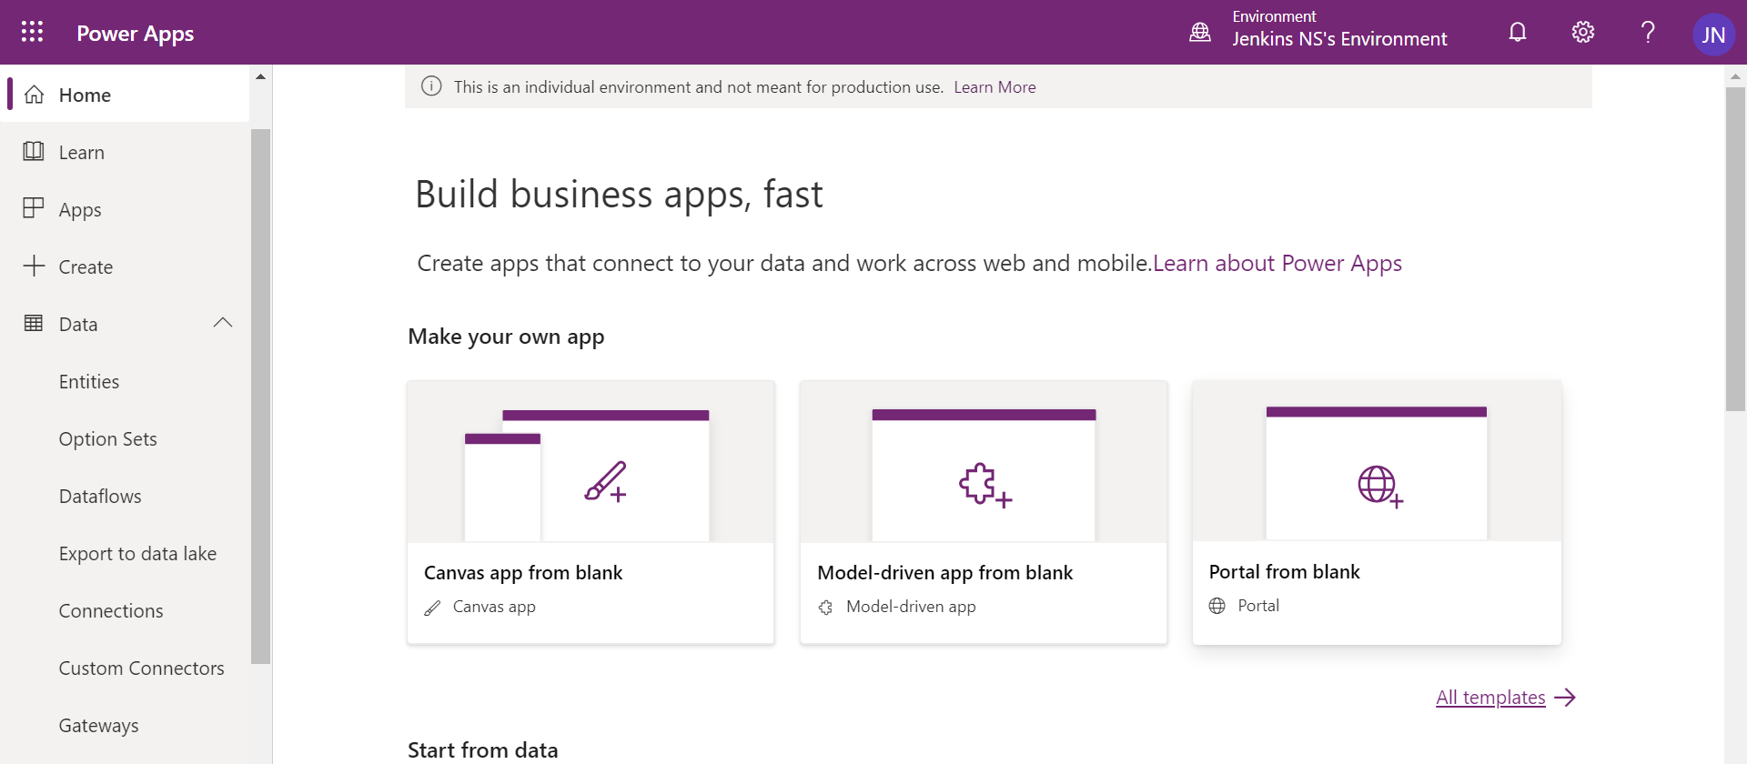

1. Click **Custom Connectors** under **Data**.

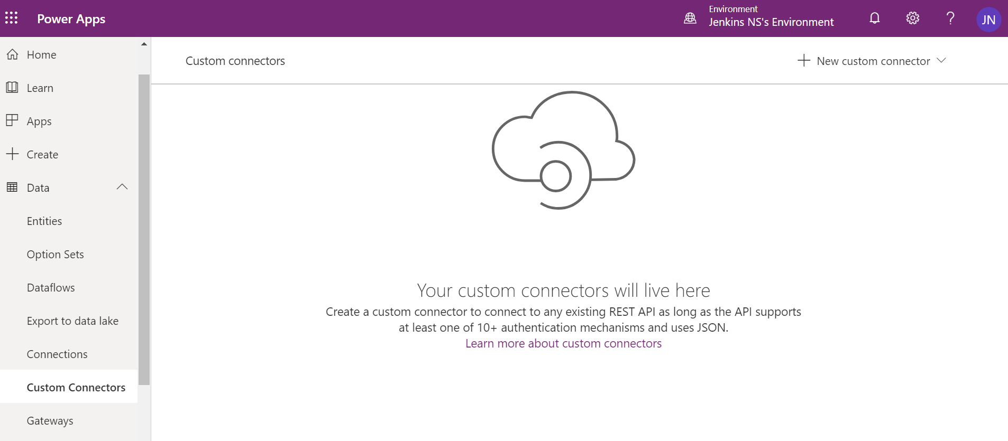

1. Click ‘**New Custom connector**’ in the right-hand side.

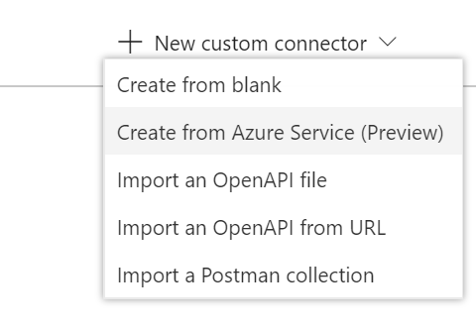

1. Select **Create from blank**.
2. Give name for the connector as **GetGoogleBooks**.

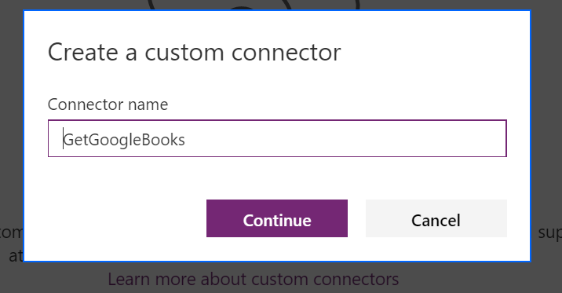

1. It will open Create connector page.

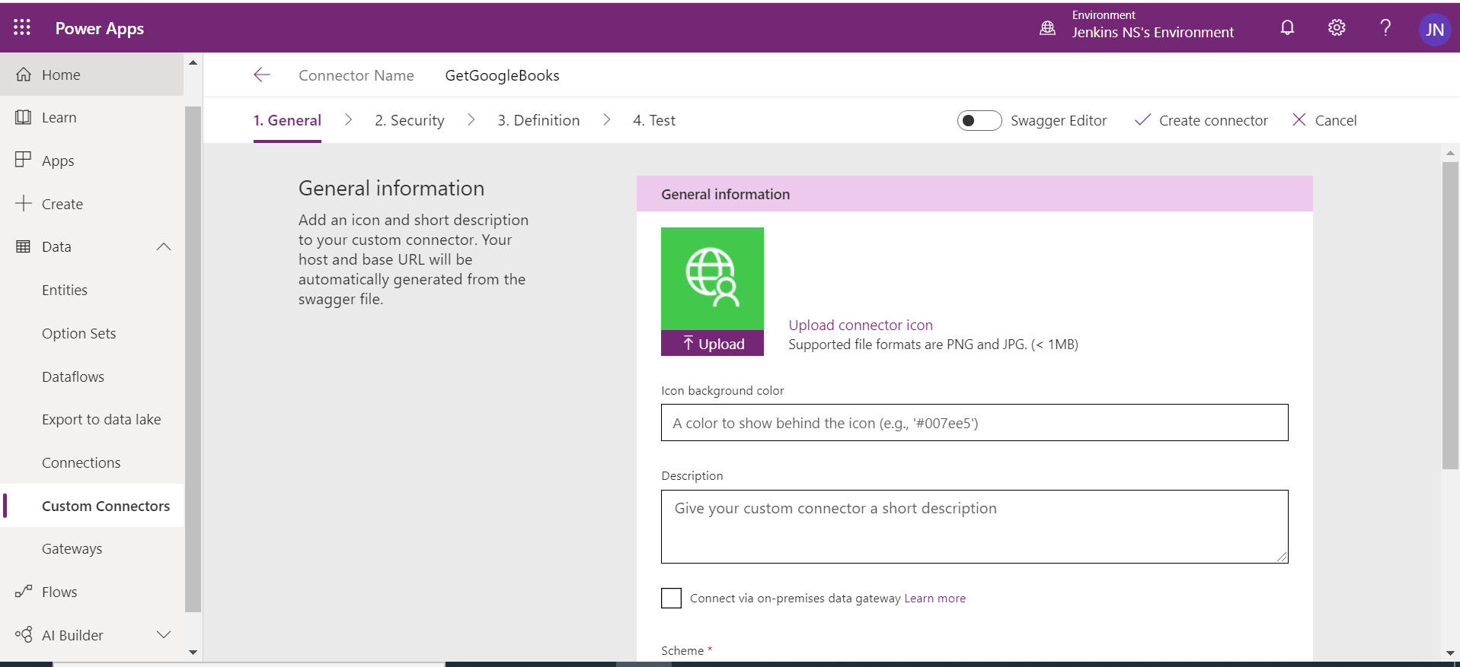

1. Fill the General Information.
2. Upload logo for the connector.
3. Set the background colour.
4. Give proper description about your connector

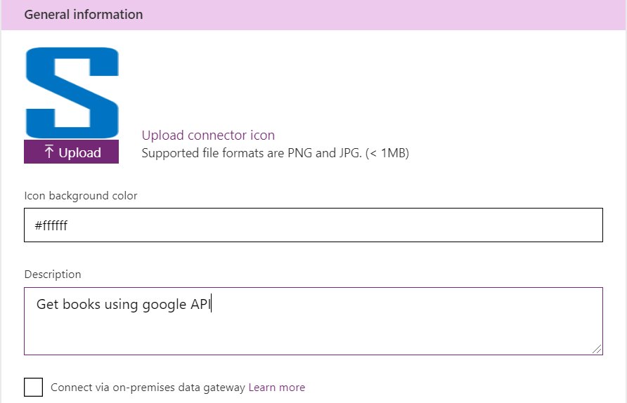

1. Scheme HTTPS
2. Host: www.googleapis.com
3. Base URL: /books/

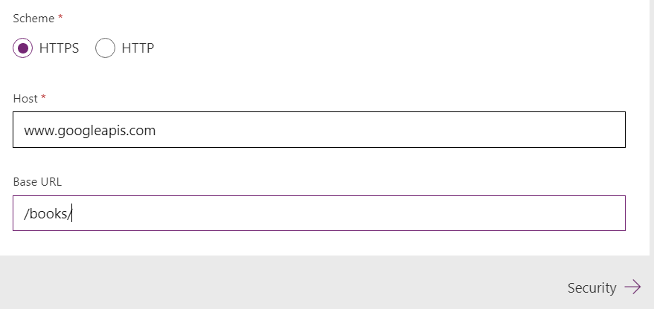

1. Click Security to move next section ‘Security’

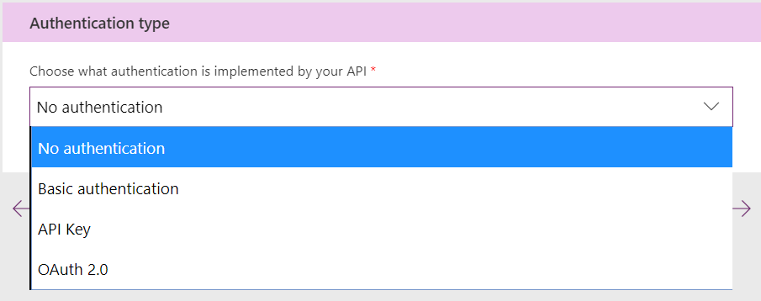

1. Select ‘**No authentication**’ for our lab exercise, because we are using open API.
2. Click ‘**Definition**’ to move next section.

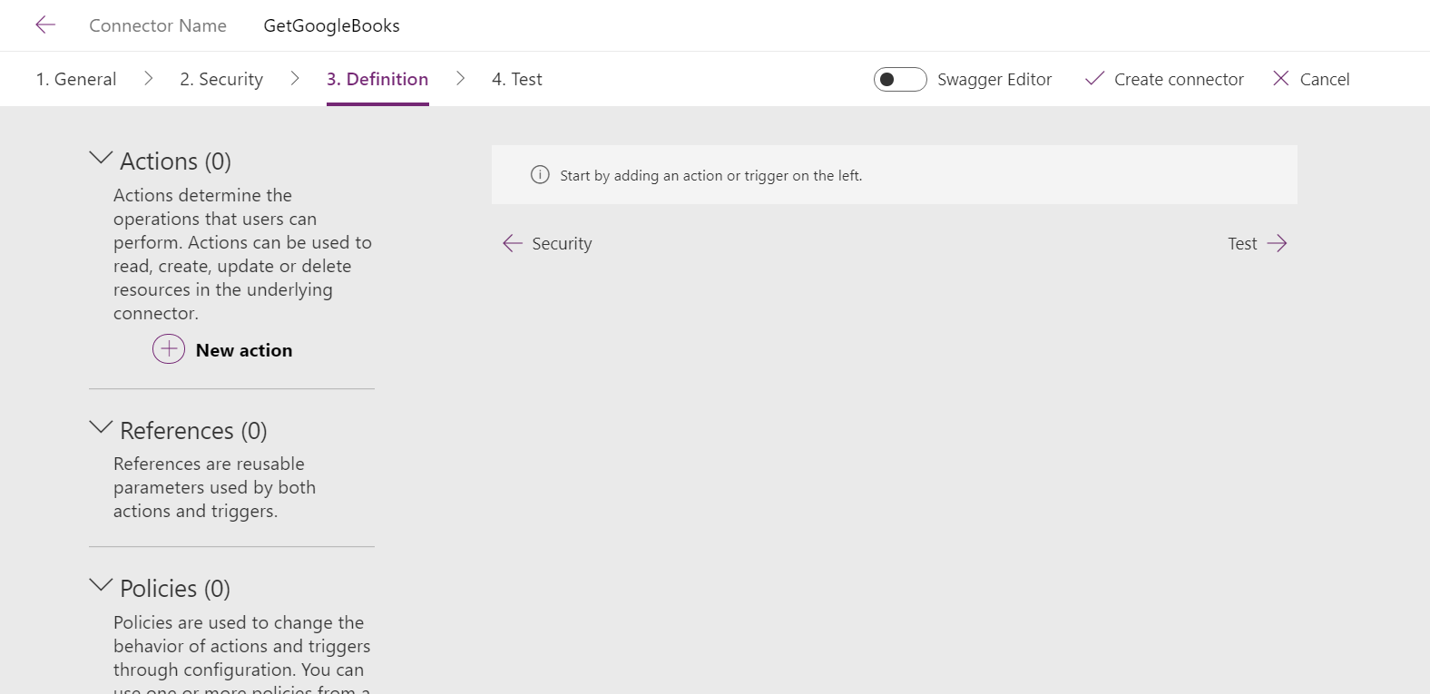

1. Add **New Action**.
   1. Add Definition
      1. Summary: Get Books Names
      2. Description: Get Books using Google API
      3. Operation ID: GetBooks
      4. Visibility: none

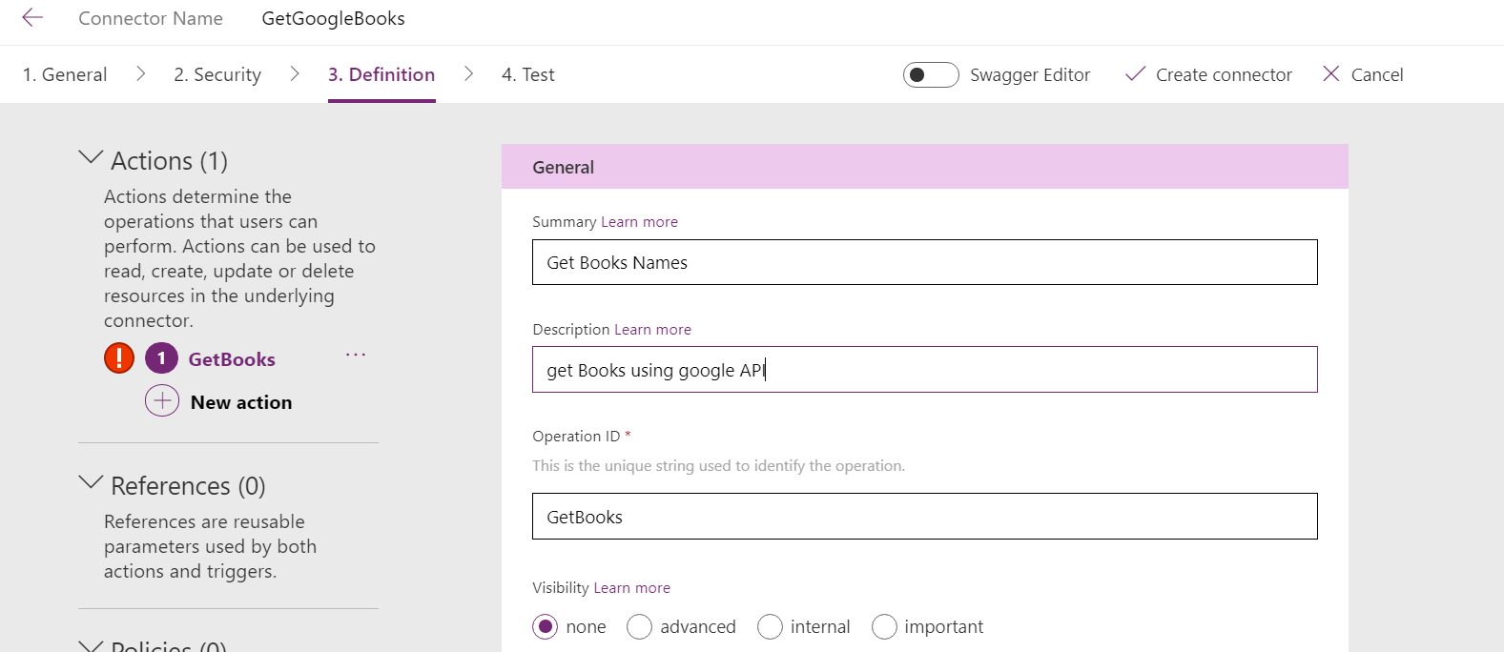

* 1. Add request - Click **Import from sample**.
     1. Verb: Get
     2. URL: <https://www.googleapis.com/books/v1/volumes?q=>
     3. Click **Import** to create request

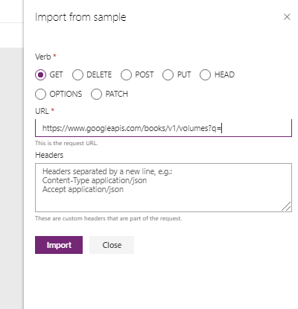

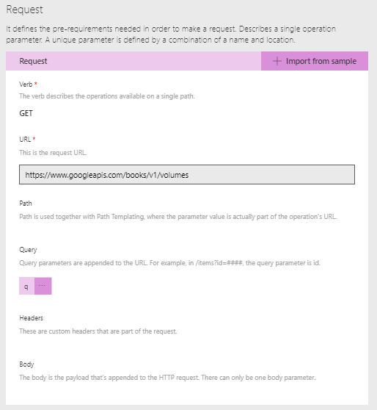

1. Add Response schema: Click default Response link

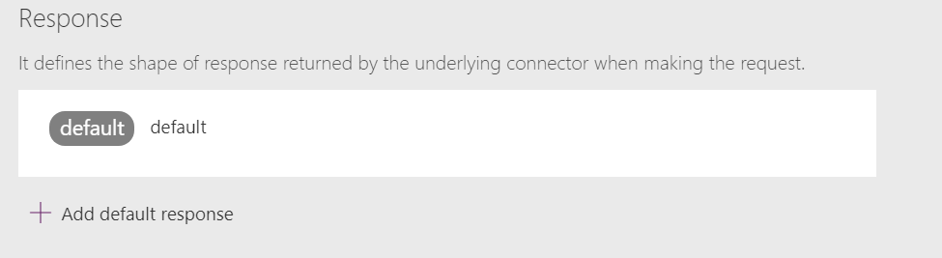

1. Click import from sample

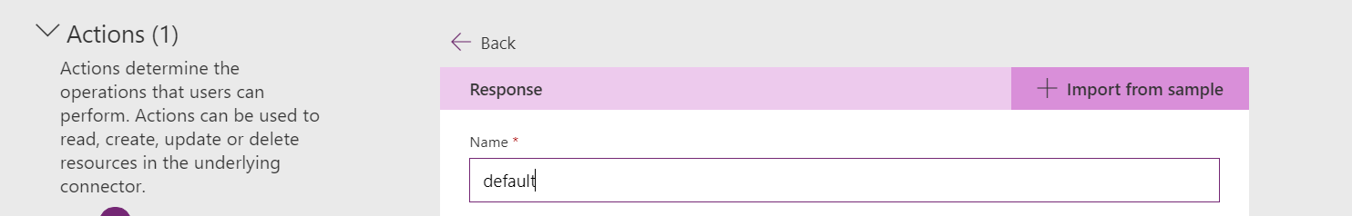

1. Open this URL in chrome browser and copy the whole response from the browser : <https://www.googleapis.com/books/v1/volumes?q=ISBN:9780789748591>
2. Paste in the body control

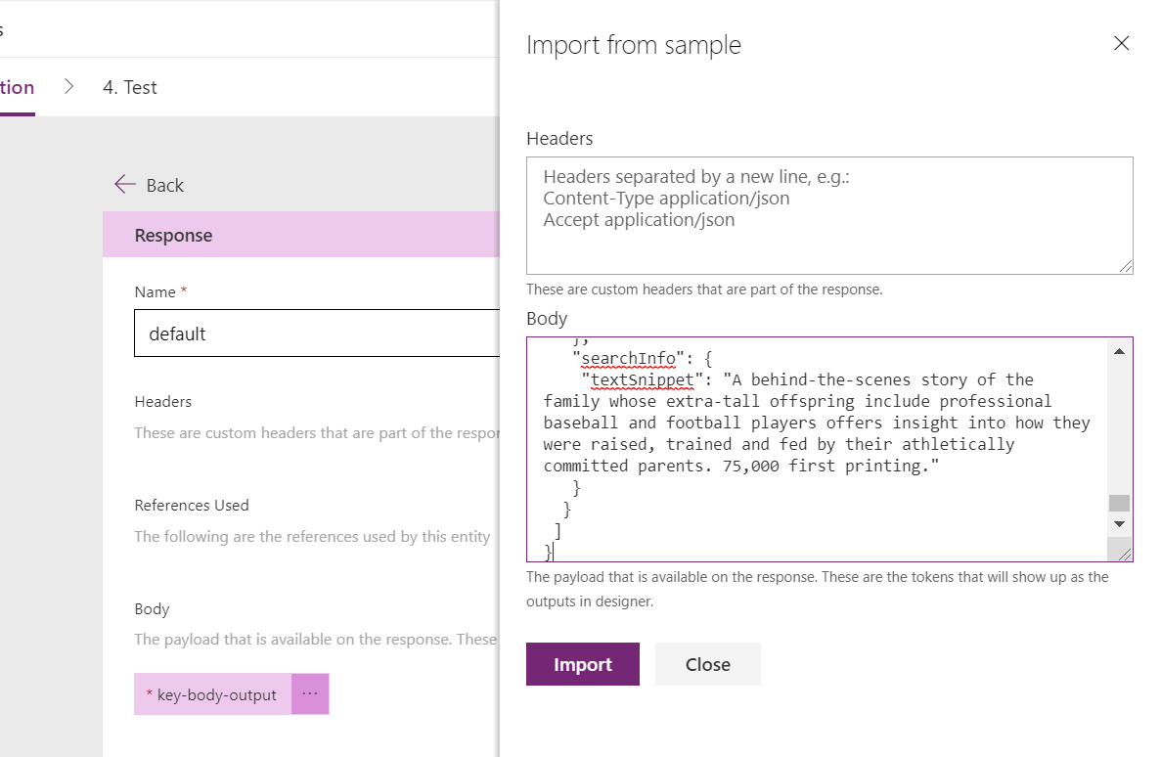

1. Click **Import** to set schema for response.

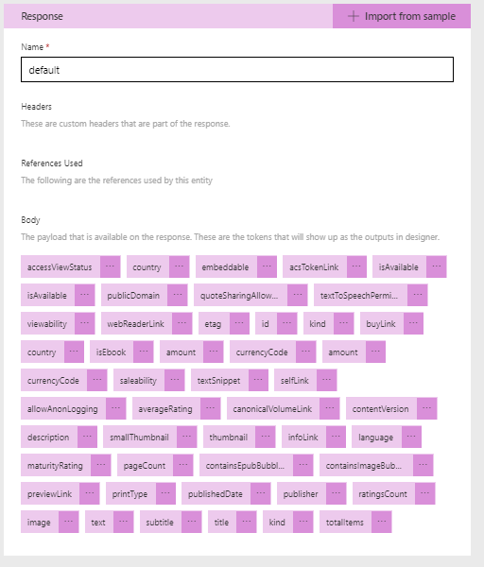

1. Click ‘Create connector’ to create the connector



1. Click Test to test the connector
   1. Create New connection

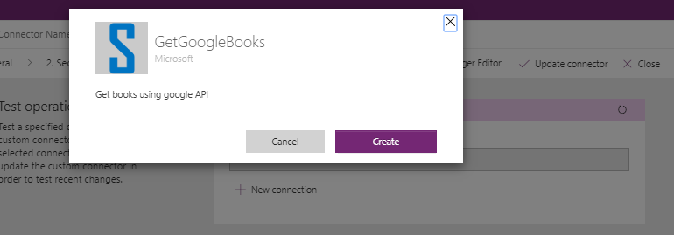

* 1. Test the connector give parameter : [ISBN:9780789748591](https://www.googleapis.com/books/v1/volumes?q=ISBN:9780789748591)

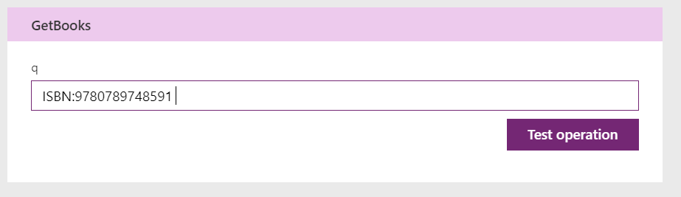

* 1. It will reply the response with 200 status

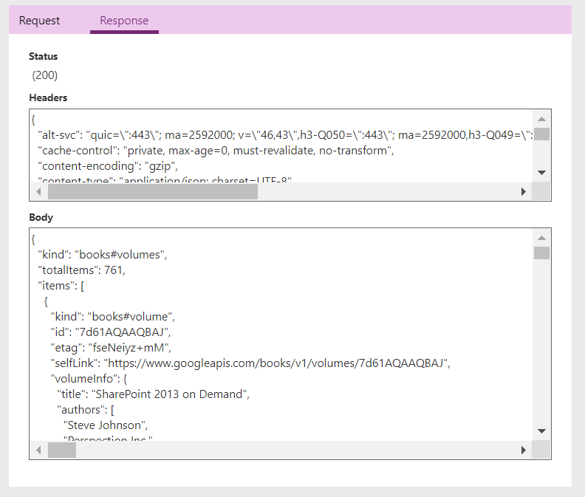

Implement custom connector in our canvas app

1. Create a canvas app

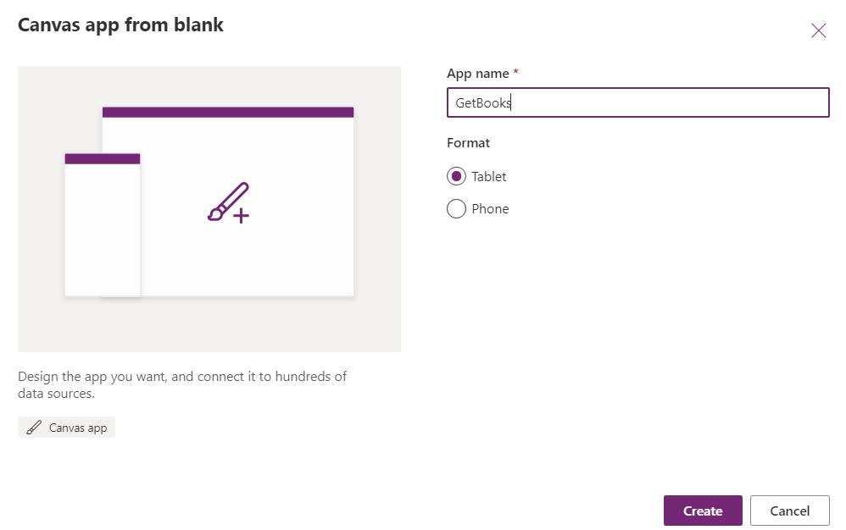

1. Click create button to create a application and skip button to skip the default form creation

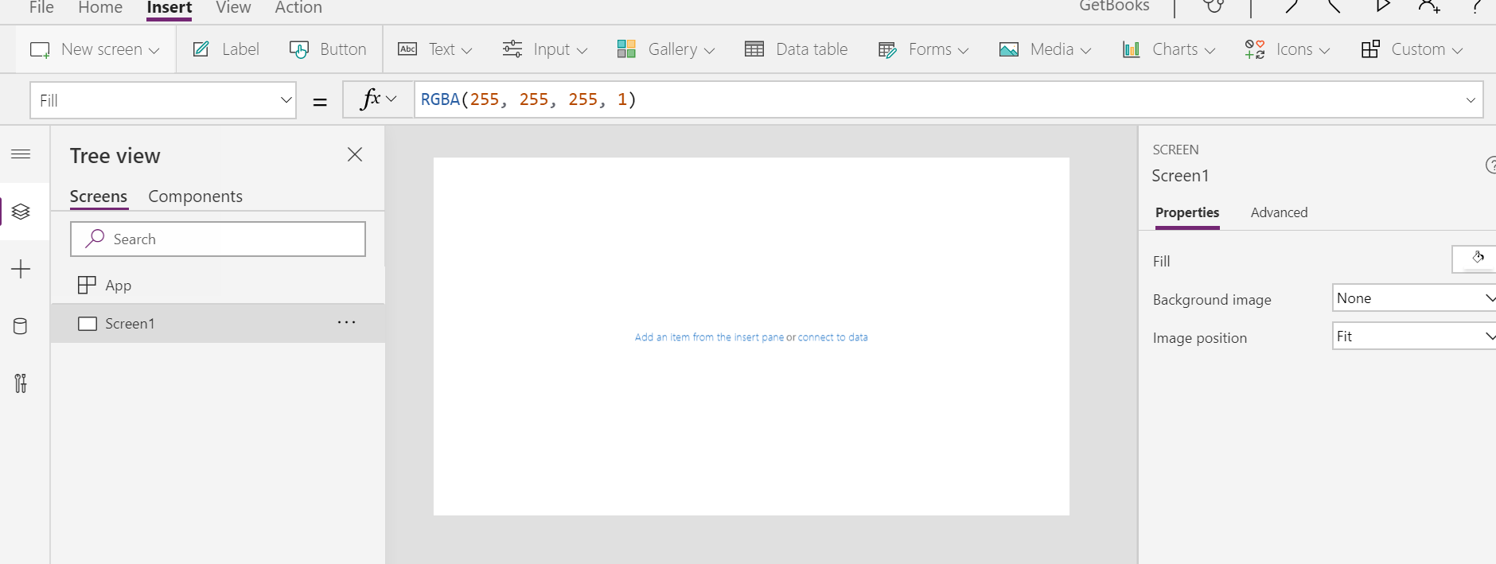

1. Click data source and connect your connector

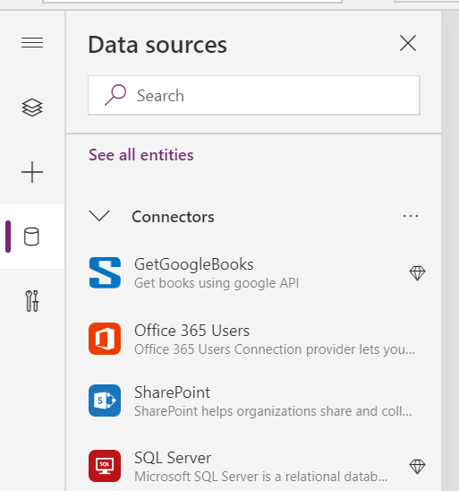

1. Select your connector ‘GetGoogleBooks’
2. Add Label Box – Enter ISBN Number
3. Add one Text Box
4. Add one Button
   1. Button OnSelect -> **Collect(mybooks,GetGoogleBooks.GetBooks({q:TextInput1.Text}))**
5. Add vertical Gallery control with Image,title nd subtile
   1. Datasource - First(mybooks).items
   2. Image: ThisItem.volumeInfo.imageLinks.thumbnail
   3. Title: ThisItem.volumeInfo.title
   4. SubTitle: ThisItem.volumeInfo.description
6. Output here

